Course: CSN 405 – Network Programming
LAB 8 – RSA & AES Python

Student name | Phan Ngọc Hạnh Nhi
Student ID | 2131209002

Question 1 - Generate RSA Key Pair
1. Use the RSA library.
2. Generate a minimum 2048-bit RSA key.
3. Save the private and public keys in PEM format.
4. Do not hardcode the key content beforehand.
5. When running the program, print a message indicating successful key generation.

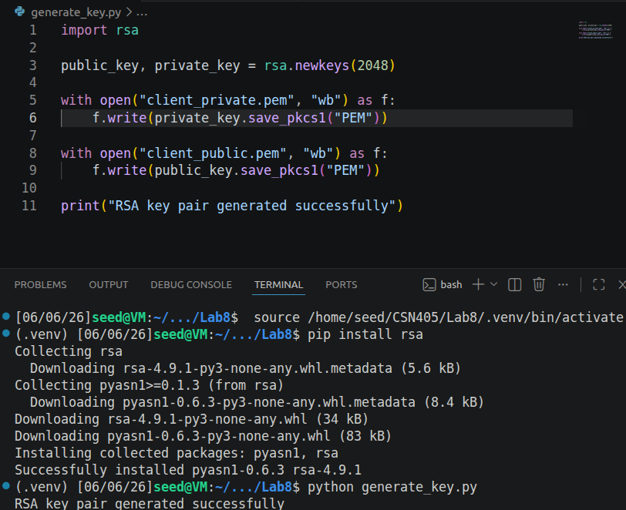
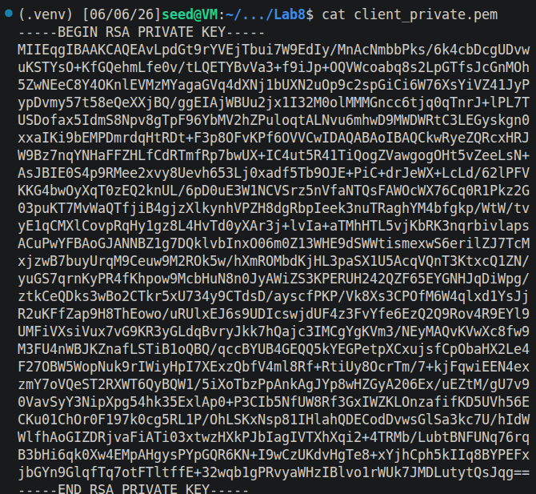
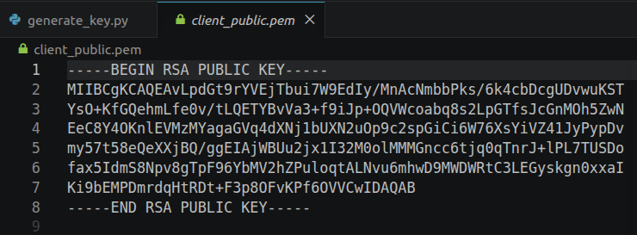

Using asynchronous method
Question 2 - Client Signs a Message
The client needs to perform the following functions:
1. Load the private key from the client_private.pem file.
2. Allow the user to input a message from the keyboard.
3. Sign the message using the RSA private key.
4. Use the SHA-256 hashing algorithm.
5. Encode the signature using Base64.
6. Send the message and signature to the server via TCP socket.
7. Receive the response from the server and print it on the screen.
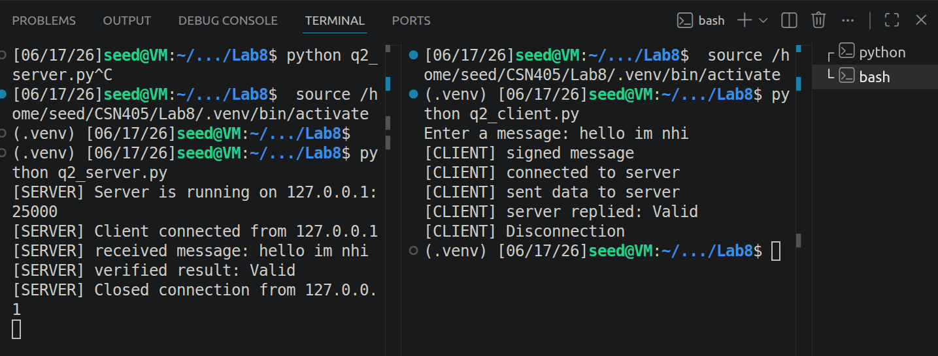
Question 3 - Server Verifies the Signature
The server needs to perform the following functions:
- Load the public key from the client_public.pem file.
- Open the TCP server at 127.0.0.1:25000.
- Wait for the client to connect.
- Receive JSON data from the client.
- Extract the message and signature.
- Decode the signature from Base64 to bytes.
- Verify the signature using the RSA public key.
- Return the result to the client.

Example: Server
[SERVER] Listening on 127.0.0.1:25000
[SERVER] New connection from 127.0.0.1
[SERVER] Received message: Hello RSA Server
[SERVER] Verification result: VALID
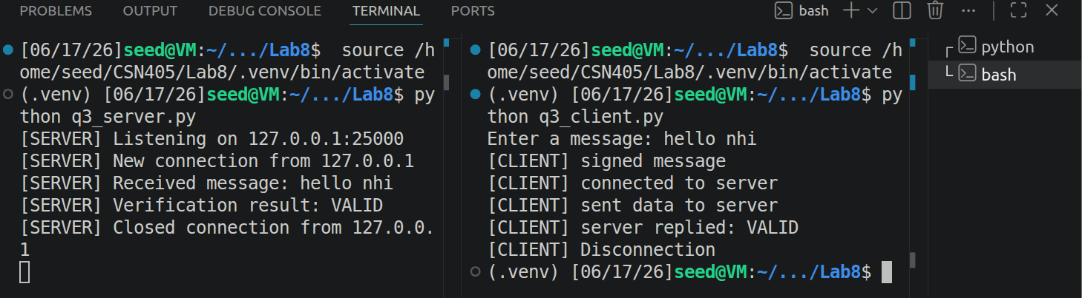

Question 4 - Tampered Message Test
Requirement
- Update client.py to check for messages being tampered with after signing.
- The client should ask the user:
- Do you want to tamper the message before sending? y/n:
- If the user selects n, the client sends the original message.
- If the user selects y, the client must:
- Sign the original message.
- Then tamper with the message before sending.
- Send the tampered message along with the original message's signature.
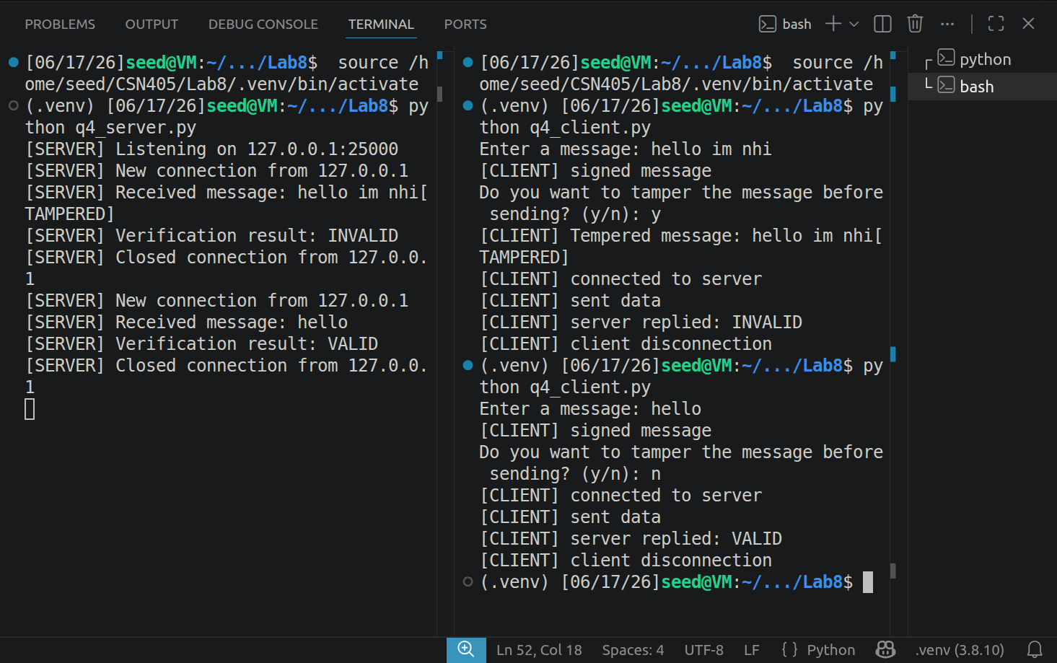
Question 5 - AES: Encrypt Message Content
RSA signatures help verify the sender and check if the message has been altered. However, the message is still sent in plain text. To further secure the message content, students can use AES.
- Generate AES Key
- AES Client
2.1 Load the AES key from aes.key.
2.2 Load the RSA private key from client_private.pem.
2.3 Enter the message from the keyboard.
2.4 Encrypt the message using AES-GCM.
  - Sign the encrypted data using the RSA private key.
  - Send the nonce, ciphertext, and signature to the server.
- AES Server
  - The AES server needs:
  - Load the AES key from aes.key.
  - Load the RSA public key from client_public.pem.
  - Receive JSON from the client.
  - Verify the signature first.
  - If the signature is valid, decrypt the ciphertext.
  - If the signature is invalid, do not decrypt the message.
Expected results
If valid:
[SERVER] Signature result: VALID
[SERVER] Decrypted message: Hello AES RSA

If invalid:
[SERVER] Signature result: INVALID
[SERVER] Message rejected.
